Resume 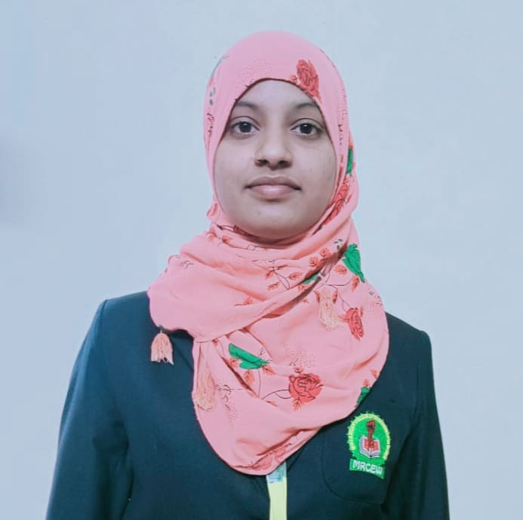

SHAIK.HANIFA



Phone no.8688335344

Email id: shanifa787@gmail.com

CAReeR OBJeCTIVe:-

Looking forward for challenging Carrer opening, which provides me sample opportunities to Entend my knowledge and Retine my skills. So that I can be a dynamic asset to the organization

|  |  |  |  |  |  |  |
| --- | --- | --- | --- | --- | --- | --- |
| ACADemIC OBJeCTIVe:- | | | | |  | |
|  | **COURSE** | **INSTITUTE** | **BOARD/UNIVERSITY** | **YEAR OF PASSING** | **%GPA** |  |
| B-TECH | MALLA REDDY  ENGINEERING  COLLEGE FOR  WOMEN | JNTUH | PURUSUING | - |
| INTERMEDIATE | TMR  JUNIOR  COLLEGE | BOARD OF  INTERMEDIATE  EDUCATION TS | 2022 | 65% |
| SSC | KGBV SCHOOL | BOARD OF SECONDARY EDUCATION TS | 2020 | 100% |

TeCHNICAL QuALIFICATION

* Basic Computer Knowledge
* Basic Knowledge In Python
* Programming Language:- C Language ,Java.

sKILLs

* Confident And Determined
* Good Communication Skills
* Quick Learner

ACHIeVemeNTs &eXTRA CuRRICuLAR

* Ceritified For Participating In National Programme On Technology Enhanced Learning (NPTEL)
* Technical English for Engineerings (NPTEL)
* Gold Medal In The Association Of Mathematics Teachers Of India Exam (AMTI)
* Student Ambassador For Telangana Academy For Skills And Knowledge(TASK)

PeRsONAL PROFILe

|  |  |
| --- | --- |
| **NATIONALITY** | **:** INDIAN |
| **GENDER** | **:** FEMALE |
| **DATE OF BIRTH** | **: 16-06-2005** |
| **FLEXIBILITY TO TRAVEL** | **: 100%** |
| **LANGUAGE KNOWN** | **:** TELUGU,ENGLISH,URDHU |
| **HOBBIES** | **:** Dancing ,Singing, Reading books |

**DECLARATION:-**

I here by declare that above information is correct to the best of my knowledge and belief.

**PLACE:**

**DATE:**